Just wait for the bus…

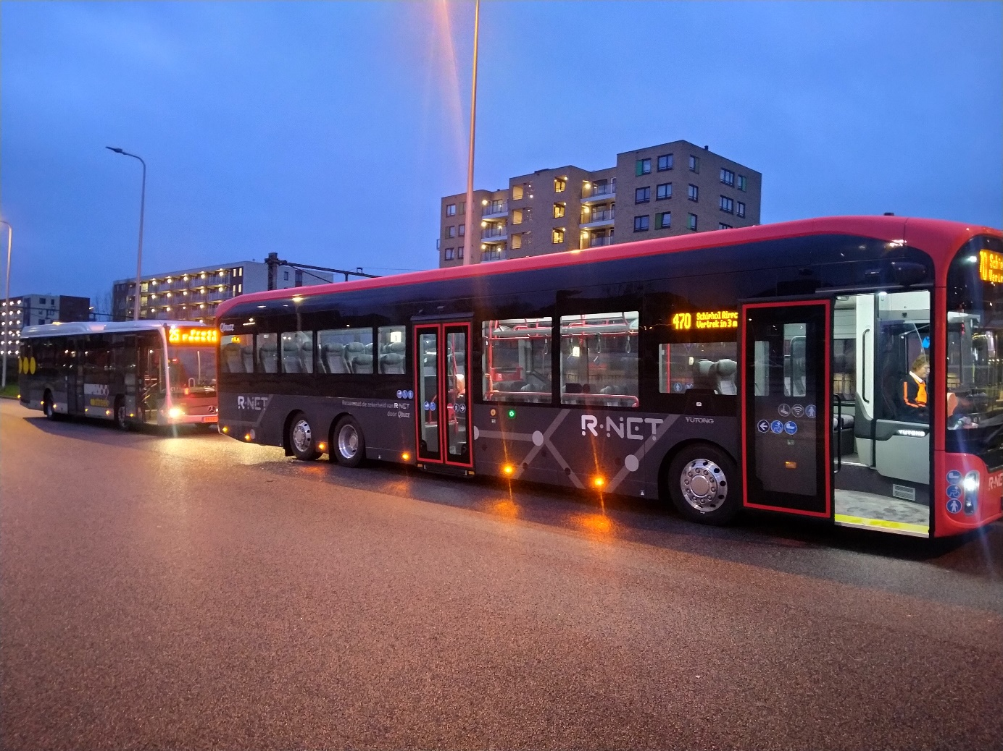

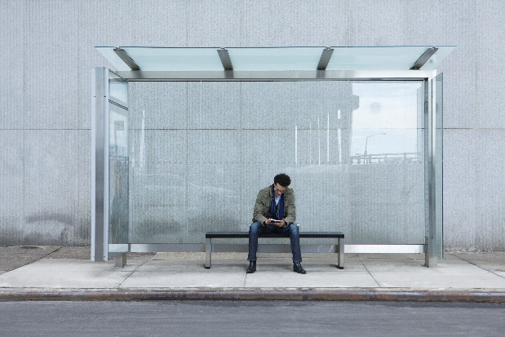
Preliminary round Mathematics A-day 2025
Obs brug af AI i arbejdet er ikke tilladt
Work instructions for the preliminary round assignment of the Mathematics Alympiad 2024/2025
This preliminary round assignment consists of a total of five assignments. All the knowledge and insights that are gained in the first four assignments can (and must) be applied in the final assignment. The assignments build on each other and are connected, so do them in the prescribed order.
General advice when working on this Alympiad assignment:
- First read the entire text of the assignment so you will know what you have to do.
- It may be necessary to make (additional) assumptions for this assignment. Provide a clear description and justification of your choices.
- The assignments build on each other and are connected: you will need what you learned in one assignment in the next one… so do not divide the work but do everything together!
- Keep an eye on the time you spend on the first assignments; take plenty of time for the final assignment.
- Don't make it too easy on yourself in the final assignment... After all, this is the assignment that will make you stand out from the rest!
- If you make changes to your approaches, methods or procedures while working on the assignments, describe these in your report and explain why you made them.
- Mention any (internet) sources you use.

To hand in:
- The final assignment
- The previous assignments, possibly as attachment(s)
When your work is submitted, the jury will receive a digital copy of your work. If you have any attachments to the paper, submit everything in a zipped folder. Include the name of the school and your own names in the file name.

Assessment:
The assessment may take into account, among other things:
- the readability and clarity of the final assignments;
- the completeness of the work;
- the use of mathematics;
- the argumentation used and the justification for choices made;
- the depth with which things have been done;
- the method of presentation: including the form, readability, structure, use and function of appendices;
- the (mathematical) creativity in the elaboration of the assignments.


Have fun and good luck!

Part 1 – The start of AmberBus
In the city of Amberhavn, public transport is operated by the AmberBus company. AmberBus is investigating which timetable best suits the needs of passengers. One bus line, number 1, in the city, runs from the station to the hospital. The journey from Amberhavn station to the hospital takes 20 minutes. At the hospital, the bus turns around and immediately returns to the station. After 40 minutes, the bus is back at the station. We call the journey from Amberhavn station via the hospital back to Amberhavn station a trip.
AmberBus is investigating two possible timetables:
• Timetable A, with a bus leaving the station for the hospital every half hour every day.
• Timetable B, with a bus leaving every 15 minutes.
For both timetables, the first bus leaves the station at 6:00 a.m. and the last at midnight (24:00). The departure times at the station are indicated as follows at the bus stop:
Departure times bus line 1 from Amberhavn Station to Hospital

Hour | Minutes
-----------------------
06 | 00 30
07 | 00 30
08 | 00 30
09 | 00 30
10 | 00 30
11 | 00 30
12 | 00 30
13 | 00 30
14 | 00 30
15 | 00 30
16 | 00 30
17 | 00 30
18 | 00 30
19 | 00 30
20 | 00 30
21 | 00 30
22 | 00 30
23 | 00 30
24 | 00
Hour | Minutes
-----------------------
06 | 00 15 30 45
07 | 00 15 30 45
08 | 00 15 30 45
09 | 00 15 30 45
10 | 00 15 30 45
11 | 00 15 30 45
12 | 00 15 30 45
13 | 00 15 30 45
14 | 00 15 30 45
15 | 00 15 30 45
16 | 00 15 30 45
17 | 00 15 30 45
18 | 00 15 30 45
19 | 00 15 30 45
20 | 00 15 30 45
21 | 00 15 30 45
22 | 00 15 30 45
23 | 00 15 30 45
24 | 00

Before AmberBus decides on the final timetables, they investigate how many buses they will need for either of the two timetables (A and B).
Assignment 1
Carry out this investigation. Explain clearly how you approached it and which timetable you recommend to AmberBus.
Assignment 2
AmberBus employs four bus drivers. Investigate whether it is possible to implement timetable B with these four drivers. Include your arguments and, if applicable, any assumptions and/or choices you have made.
Part 2 – The optimal timetable
AmberBus has been operating for some time and is getting feedback that the timetable is not quite optimal yet. To get more information, AmberBus, together with the local council, conducted a survey among passengers and drivers. Among other things, this revealed that rush hour journeys are very crowded, which means that passengers often have to stand or are sometimes even unable to travel. In the evening, however, the buses are very quiet and sometimes even empty. This is obviously costly! Furthermore, the drivers are not always happy with their schedules: sometimes there are too many short breaks, or they drive two short shifts with long breaks in between.
Based on these results, AmberBus and the municipality of Amberhavn have jointly proposed a new “optimal” timetable:
Departure times bus line 1 from Amberhavn Station to Hospital
Hour | Minutes
-----------------------
06 | 00 30
07 | 00 15 30 45
08 | 00 15 30 45
09 | 00 15 30 45
10 | 00 30
11 | 00 30
12 | 00 30
13 | 00 30
14 | 00 30
15 | 00 30
16 | 00 15 30 45
17 | 00 15 30 45
18 | 00 15 30 45
19 | 00 30
20 | 00 30
21 | 00 30
22 | 00
23 | 00
24 | 00

Also, clearer guidelines have been laid down for drivers' schedules, including statutory rest and driving times:
- a break takes at least 45 minutes
- a driver may not drive without a break for more than four consecutive hours
- a driver may drive a maximum of two blocks per day
- the total working time per day (including break) may not exceed 9 hours
In addition, there is a design for a personal shift roster for drivers, so that the driver knows exactly which trips he has to make. Here is an example:
Shift roster driver (including breaks)
 | Trip nr. | Departure time | Finishing time | Starting location | Comment
blok 1 | 1 | 06:00 | 06:40 | station
blok 1 | 2 | 07:00 | 07:40 | station
blok 1 | 3 | 08:00 | 08:40 | station
blok 1 | 4 | 09:00 | 09:40 | station
 | break | 09:40 | 10:30 |  | 50 minute break
blok 2 | 5 | 10:30 | 11:10 | station
blok 2 | 6 | 11:15 | 11:55 | station
blok 2 | 7 | 12:00 | 12:40 | station
blok 2 | 8 | 12:45 | 13:25 | station
blok 2 | 9 | 13:30 | 14:10 | station

Total shift time (including break)
Starting time | 06:00
Finishing time | 14:10
Shift time | 08:10

Assignment 3
Find out how many buses and drivers are needed for this new “optimal” timetable. Indicate how you will divide the buses across trips and create a shift roster for each driver. Again, provide arguments and any advantages and disadvantages of your choices. Also describe to what extent you consider this new timetable to be an improvement.
Tip: use a graphical representation.

Part 3: The future of AmberBus

So far, we have discussed the timetable, the buses, and the drivers, but what about the sustainability of the buses? The Amberhavn City Council attaches great importance to a healthy living environment. Air quality is of vital importance in this regard. Amberhavn therefore wants to switch to zero-emission transport. This means that from next year onwards, only electric buses will be allowed to operate. However, this does create new problems, because a bus battery can run out and you can't drive an empty bus! Charging stations will therefore be installed at Amberhaven station so the buses can be recharged.
The degree to which the battery is charged is called State of Charge (SoC), a number between 0 and 100 that indicates the percentage of charge in the battery.
Limitations electrical buses
- With a full battery the SoC equals 100.
- For each trip on bus line 1 the SoC reduces by 15.
- A bus must be charged when the SoC is 10, but earlier is allowed! You do not want to run the risk to come to a halt, so you want to avoid a SoC below 10!
- When charging, the SoC increases by 1 per minute.

Assignment 4
Investigate the maximum number of trips an electric bus can make in a day if the bus starts at 06.00.
The council is wondering how many extra buses and drivers are needed to make zero-emission driving a success. Your A-day team has been tasked with advising the council on this.
Assignment 5
Write a well-founded recommendation to the council. Naturally, you will use your previous findings from the assignment.

Colophon
The Mathematics Alympiad is an initiative of the Freudenthal Institute, Utrecht University. The Alympiad committee is responsible for organizing the Alympiad and producing the assignment. The committee consists of:
Richard Both
St. Nicolaaslyceum, Amsterdam
Tom Goris
Fontys Teacher Training, Tilburg
Dédé de Haan
Freudenthal Institute, Utrecht University
Senta Haas
Städtisches Gymnasium Hennef, Hennef, Germany
Kim Kaspers
Lyceum Sancta Maria, Haarlem
Johan van de Leur
Mathematical Institute, Utrecht University
Ruud Stolwijk
CITO, Arnhem; Vrijeschool Zutphen VO, Zutphen
Monica Wijers
Freudenthal Institute, Utrecht University

Secretariat:
Mariozee Wintermans
Freudenthal Institute, Utrecht University

WiT is sponsored by:

