Cutting down on Christmas

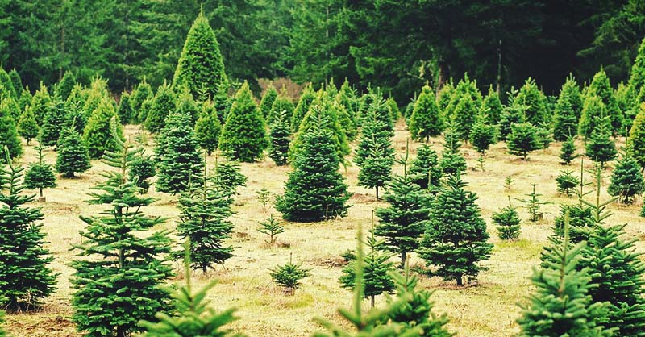

Preliminary round Alympiad 2024-2025


Work instructions for the preliminary round assignment of the Mathematics Alympiad 2024/2025
This preliminary round assignment consists of a total of five assignments: three starting assignments, a middle assignment and a final assignment. All the knowledge and insights that are gained in the first four assignments can (and must) be applied in the final assignment.
General advice when working on this Alympiad assignment:
- First read the entire text of the assignment so you will know what you have to do.
- It may be necessary to make (additional) assumptions for this assignment. Provide a clear description and justification of your choices.
- Using spreadsheet software (like Excel) is recommended for this preliminary round assignment
- The assignments build on each other and are connected: you will need what you learned in one assignment in the next one… so do not divide the work but do everything together!
- Keep an eye on the time you spend on the first assignments; take plenty of time for the final assignment.
- Don't make it too easy on yourself in the final assignment... After all, this is the assignment that will make you stand out from the rest!
- If you make changes to your approaches, methods or procedures while working on the assignments, describe these in your report and explain why you made them.
- Mention any (internet) sources you use.

To hand in:
- The final assignment
- The previous assignments, possibly as attachment(s)
- When your work is submitted, the jury will receive a digital copy of your work. If you have any attachments to the paper, submit everything in a zipped folder. Include the name of the school and your own names in the file name.

Assessment:
The assessment may take into account, among other things:
- the readability and clarity of the final assignments;
- the completeness of the work;
- the use of mathematics;
- the argumentation used and the justification for choices made;
- the depth with which things have been done;
- the method of presentation: including the form, readability, structure, use and function of appendices;
- the (mathematical) creativity in the elaboration of the assignments.

Have fun and good luck!

Introduction
In Amberhavn, people celebrate Christmas enthusiastically. Many ‘real’ Christmas trees are put up. Residents buy a Christmas tree to put up at home, and the municipality buys large trees that are given a place in the city. As a result, there are several Christmas tree growers around Amberhavn: Amber Christmas is one of them. In this task, we follow the company Amber Christmas for several years.

Starting assignments
Amber Christmas has an area of land on which 3,000 Christmas trees can grow. The company classifies the trees into three categories: small, medium and large trees. Just after Christmas 2020, there were 1,000 trees left in each category.
From experience, the grower knows approximately how fast the trees grow over a period of (almost) one year: 40% of small trees become medium-sized, so 60% remain small; 20% of medium-sized trees become large; a large tree remains large.

- Represent the above information graphically.

- What will be the composition of the forest after one year, around Christmas 2021?

- If the grower were to do nothing, i.e., not cut down or replant any trees, the forest will eventually consist of only large trees. Give a reasoned estimate after how many years this will be the case.

Middle assignment
Amber Christmas needs trees in every category. The grower wants to create a stable growth situation and stable sales. He asks himself how he can cut and replant Christmas trees in the most favourable way possible. He considers the following three strategies:

- After 1 year, cut some medium and large trees for sale and then replant small trees so that there are 1,000 trees in each category again.
- Cut down to a number of medium and large trees only after 2 years and replant small trees so that there are 1,000 trees of each category again.
- After 1 year, only cut down large trees (so that 1000 remain) and replant the same number of small trees; after the second year, only cut down large trees (over 1000) and replant the same number of small trees.

Large trees yield twice as much as medium-sized trees when sold. Amber Christmas finds the small trees unsuitable for sale.

- Give the grower well-founded advice on which of the three strategies is the best choice in the long run.

Final assignment
Amberhavn will expand further in 2025, and the Amber Christmas nursery will then have to move. The new area of land for the trees is the same size as the old one, so 3000 Christmas trees can grow there again. The relocation creates a new situation: new trees will have to be planted and a new strategy for felling and planting (the felling and planting scheme) can be developed.
Amber Christmas decides to switch to a different type of tree: the Amber fir. The grower conducted two surveys prior to the move: a survey of Ambers fir growth and a survey among their customers.
Age of tree in years | Height (cm)
1 | 26
2 | 70
3 | 119
4 | 181
5 | 253
6 | 331
7 | 398
8 | 463
9 | 527
10 | 589

Growth of the Amber fir
The table on the right shows data on the average height of an Amber fir in its first 10 years of growth.

The graph below shows the growth rate of an Amber fir over 10 years. Not every tree grows at the same rate, which is why the graph consists of boxplots. Each boxplot consists of 4 quartiles, each containing 25% of the trees.

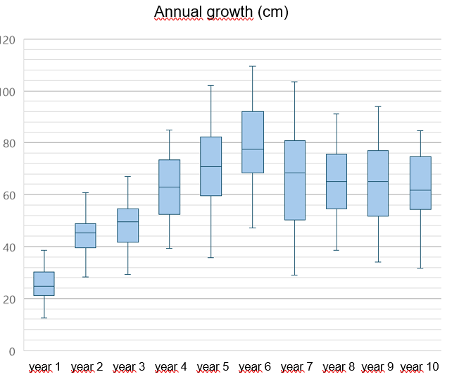

In the boxplot, you can for example read that of the 3-year-old trees:
- 25 percent grew between 39 and 53 cm in the 4th year
- 25 percent grew between 53 and 63 cm in the 4th year
- 25 percent grew between 63 and 72 cm in the 4th year
- 25 percent grew between 72 and 85 cm in the 4th year

Customer survey
The customer survey asked, among other things, what height of Christmas tree customers prefer. These data were combined with sales data from previous years. These are the (rounded) results.
- About 25% want a tree smaller than 1.20 metres
- About 65% want a tree between 1.50 and 2.50 metres
- About 10% want a tree taller than 4 metres

Most customers indicated in the survey that if there were no other trees left, they would also be willing to buy a slightly larger or slightly smaller tree.

Finally, the customers' wish is that there should no longer be one price per category of trees (medium and large), but that the price should be determined by the height of the tree: the taller the tree, the higher the price.

Final assignment
In autumn 2025, Amber Christmas will plant the new plot. They can plant 1-, 2- or 3-year-old trees. They want to be able to sell trees before Christmas 2026 (i.e., 1 year after planting). They expect to have a felling and planting schedule that is stable no later than 5 years later and that allows them to meet customer demands.

Draw up a schedule for Amber Christmas. Give the planting schedule for 2025 and determine sales (felling) and new planting for subsequent years. Make sure that the felling and planting schedule is stable after at most 5 years and that Amber Christmas can then meet all customer demands.

In any case, keep the following in mind:
- Amber Christmas will (eventually) need 500 trees for sale every year.
- A maximum of 3,000 trees can grow on the plot.
- Amber Christmas wants to meet the wishes from the customer survey as much as possible right from the start.
- Amber Christmas can plant trees each year with an age of 1, 2 or 3 years.
- The price of the trees they plant depends on their age (and therefore height): the older (taller), the more expensive.
- After 5 years at most, they want to be able to use the same felling and planting schedule every year. In the years before that, the felling and planting schedule may still change from year to year.

Write a report that clearly and visually explains and substantiates the planning and outcomes for Amber Christmas from 2025 onwards.

Colophon
The Mathematics Alympiad is an initiative of the Freudenthal Institute, Utrecht University. The Alympiad committee is responsible for organizing the Alympiad and producing the assignment. The committee consists of:
Marcel Daems
Gymnasium Sorghvliet, The Hague
Tom Goris
Fontys Teacher Training, Tilburg
Dédé de Haan
Freudenthal Institute, Utrecht University
Senta Haas
Städtisches Gymnasium Hennef, Hennef, Germany
Kim Kaspers
Lyceum Sancta Maria, Haarlem
Johan van de Leur
Mathematical Institute, Utrecht University
Ruud Stolwijk
CITO, Arnhem; Vrijeschool Zutphen VO, Zutphen
Monica Wijers
Freudenthal Institute, Utrecht University
Secretariat:
Mariozee Wintermans
Freudenthal Institute, Utrecht University

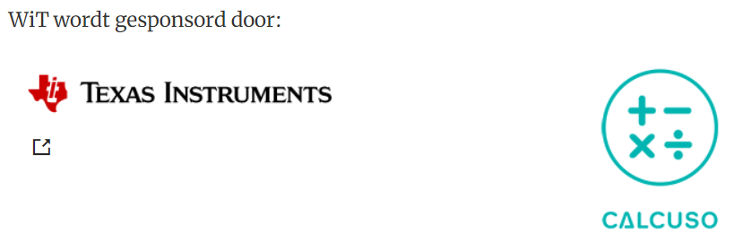
This 36th Alympiad assignment is a tribute to Jan de Lange, who coined the concept of the ‘Alympiad’ and stood at the basis of this assignment.
WiT is sponsored by:

