Vaccinating meaningfully



Preliminary round Alympiad November 16, 2018

Colophon
The Mathematics Alympiad (Wiskunde Alympiade) is an initiative of the Freudenthal Institute, Utrecht University. The Alympiad committee is responsible for the organisation of the Alympiad and for producing the assignment. The committee consists of:

Tom Goris
Fontys Lerarenopleiding,Tilburg
Dédé de Haan
Freudenthal Instituut, Utrecht University
Senta Haas
Städtisches Gymnasium Hennef, Hennef, Duitsland
Jacques Jansen
Strabrecht College, Geldrop
Kim Kaspers
Murmellius Gymnasium, Alkmaar
Johan van de Leur
Mathematisch Instituut, Utrecht University
Ruud Stolwijk
CITO, Arnhem; Vrijeschool Zutphen VO, Zutphen
Monica Wijers
Freudenthal Instituut, Utrecht University

Secretariat:
Liesbeth Walther and Mariozee Wintermans
Freudenthal Institute, Utrecht University

Guide for the preliminary round assignment for the 2018/2019 Mathematics Alympiad
This Mathematics Alympiad assignment consists of five (exploratory) assignments and two final assignments. The first five assignments are a run-up to the final assignments: all the knowledge and insights from these assignments can be applied in the final assignments.
General advice for working on this assignment:
- First read the full text of the assignment so you will know what you have to do.
- Keep an eye on the time you spend on the first five assignments; take plenty of time for the final assignments, at least three hours.
- If you divide up tasks within your team, discuss the results with each other after every assignment.
- Several questions use the word ‘research’. Always indicate clearly for these questions what you research, possibly research simpler problems, go further than ‘just answering the question’, research alternatives. These will be criteria that the quality of your elaboration will be judged on.
- If you adapt certain approaches, methods or procedures while working on the assignments, describe your adaptations in your report and include why you made them.
- It may be a good idea to use Excel or another spreadsheet program for this assignment.

Handing in:
• The two final assignments
• Assignments 1 to 5 as appendices

When you hand in your work, the jury will receive a digital copy. If you have any appendices with your work, hand in everything in a zipped folder. Include the name of your school and your own names in the file name.
Judging:
These are some of the points that may be considered by the jury:
- Legibility and clarity of the final assignment;
- How complete the work is;
- The use of maths;
- The argumentation used and justifications of choices that have been made;
- The depth to which the various assignments have been answered;
- Presentation: form, legibility, structure, use and function of illustrations;
- (Mathematical) creativity in your elaboration of the assignments.

Have fun and good luck!

Introduction
Throughout history infectious diseases have caused millions of deaths. An apparently innocuous disease like the flu still claimed many victims in the twentieth century: more people died from the Spanish flu epidemic in 1918-1919 than had died in the First World War.
Over the last months infectious diseases like meningitis (caused by meningococcus), measles and rubella have been in the news a lot. Usually vaccination (inoculation) is the most effective way to prevent an epidemic.
When you are vaccinated, a strongly weakened form of the virus concerned is injected, which causes your body to start producing antibodies against this disease. When you next encounter the real, much stronger virus, you have become immune because of the antibodies you produced, and you can no longer get ill from it.
A regularly occurring problem with vaccination is however that when there is an unexpected outbreak of a disease there are not always enough vaccine doses available to vaccinate the entire population. You must then consider which groups (and in what numbers) can best be vaccinated for the best (and safest) result. This Alympiad assignment involves making these choices, i.e. allocating the available vaccines.
First we will explore how a flu epidemic can develop, then we will investigate how vaccinating only a part of the population can prevent an epidemic.
In this assignment it is important to distinguish between the following terms:
- Someone is susceptible (V) if he or she can be infected by the flu virus.
- Someone is ill (Z) if he or she has the flu virus and can infect others.
- Someone is immune (I) if he or she is not or no longer susceptible to the flu virus; this is the case either if you have been vaccinated or if you have had the flu.
We assume that every person will always fall exactly into one of these categories.

Exploratory assignments - part A
Tom is a member of a club of 25 cycling lovers who go for a ride every Sunday (but sometimes on other days), with as many of the club members as possible taking part. Tom gets sick on Monday October 1: he has been hit by the flu. He did feel sick the previous day, but he wanted to go cycling even so. He went on a ride with Monica, Senta and Matthias that Sunday (September 30). On Thursday October 4, Matthias lets Tom know that he is also down with the flu – after going for a training ride with Ruud and Jacques the previous night when he was not feeling too well already.
Sunday October 7 Ruud, Jacques, Johan, Dédé and Kim go for a ride together. Tom, Senta and Matthias are still sick, but the rest of the club is present and taking part in the ride. Two days later Tom is almost completely well again, but now Ruud is in bed with the flu.
The day after, on Wednesday October 10, Tom is back to normal. Dédé and Kim decide to do an extra training ride that evening with everybody who is interested. Tom and Marcel arrange to go for a drink that evening. Two days later Marcel turns out to have been felled by the flu – like the others who took part in the Wednesday ride…
Sunday October 14 Tom, Monica, Senta, Matthias and four more members of the club go for a cycling ride. The rest of the club is still laid low by the flu. Another week later, finally, a large group turns up to cycle again: apart from Eric and Liesbeth everybody has recovered from the flu and is taking part in the cycling ride.
Assignment 1
Indicate for the following statements whether or not they are correct based on the story above, and explain why:
"In this club no one was immune on September 30."
"Even if you are sick, you do not necessarily feel sick."
Assignment 2
Looking back, you can state that if Tom had been vaccinated, the whole cycling club would possibly not have caught the flu… but that is hindsight, reality turned out differently! Indicate in a graphic representation the actual course of the flu wave within the cycling club.

Exploratory assignments - part B
Next you will see three graphic representations of situations in a group of a hundred people, two of whom have the flu. These have been indicated with ‘Z’. Vaccinated people – who are therefore immune – have been indicated with ‘I’. The remaining people (empty squares) are susceptible. We assume that everybody comes into direct contact with his or her ‘direct neighbours’ every day, so a maximum of four people per day.
Please note: these representations are also included in the appendix (in triplicate).
Assignment 3
Research for every representation after how many days all people will be sick – in so far as they can get sick.
Z
Z
situation 1
 |  |  | I |  |  |  |  |  | I
 | I
 |  | Z
I |  |  |  | I | I | I
 |  | I |  |  | Z
 |  |  |  |  |  |  |  | I
I
situation 2
I | I | I | I | I | I | I |  | I | I
I |  | I | I | I | I | I | I | I | I
I | I | Z |  | I | I | I | I | I | I
I | I | I | I |  | I | I | I | I | I
I | I | I |  | I |  | I | I | I | I
I | I | I | I | I | Z | I | I | I | I
 | I | I | I | I | I | I | I |  | I
I | I | I | I | I | I |  | I | I
I | I |  | I | I | I | I | I | I | I
I |  | I | I | I | I | I | I | I | I
situation 3

Assignment 4
Research for what minimum number of vaccinated people (I) the smallest possible number of the 100 people will eventually get the flue. Of course, you will make use of one or more representations like the one above.
Also discuss the situation where people ‘move freely’ and will therefore also have contact with others. For instance, consider that everybody may have four different ‘neighbours’ every day.
Middle part - assignment 5
In the preliminary assignment you could see that it is unnecessary to vaccinate everybody if you want that ‘not too many’ people catch the flu in the end. We will leave aside how much ‘not too many’ is exactly. What is important is how many people are vaccinated.
We assume here that vaccination against the flu means you will not catch the flu, i.e. that the vaccine makes you immune (I). This is what we call the direct effect of vaccination. In addition, vaccination also has an indirect effect that relates to the term herd immunity. Vaccination means that the non-vaccinated part of the population is surrounded by vaccinated people who are immune. So, people who are not vaccinated themselves will not get into contact with people who are infected, and therefore have a lower chance of infection themselves. This mechanism is what we call herd immunity.
Research shows that the indirect effect depends on the part of the population that has been vaccinated (the vaccination fraction). This is represented in the following graph (Please note: a larger version of this graph is available in the appendix):
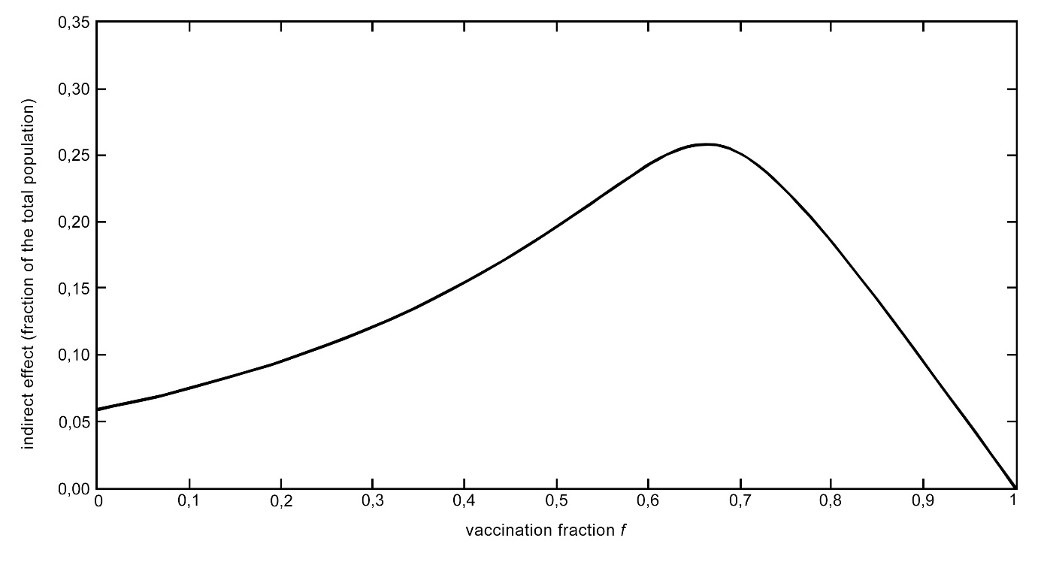In the graph you can see for instance that if half the population has been vaccinated (f = 0,5), that the indirect effect is around 0,20 and that in total almost 70% of the population is protected.
A statement from an expert (Roel Coutinho, virologist and director of the Centrum Infectieziekten [Centre for Infectious diseases): “You do not just protect yourself with vaccination, but also other people. If the coverage falls below a critical limit, the whole population is put in danger. You can see that in England, where the coverage against measles has fallen below 80%. The disease is surfacing again.”
Based on the graph above, you can make a graph showing the percentage of the population that is protected in relation to the vaccination fraction.
Research for what vaccination fractions the coverage (that is the percentage of the population that is protected) for flue comes below 80%.
Final assignment
Part 1
There are respectively 1000, 2000 and 4000 pupils in three secondary schools in Amberhavn. The board of these three schools wants to give the pupils optimal protection against the flu. However, only a limited number of vaccines is available for the schools: 3000 in total. The board wonders how to best allocate the vaccines between the schools to have as few pupils as possible catch the flu.
This question is put to you, in your role as advisory committee. Research what the effects are of different allocations, and provide a well-founded advice based on this research. You can for example illustrate your findings with graphs and tables.
You can assume that within every school all the pupils come into contact with each other, but that there is no or negligible contact between pupils from different schools.
Part 2
In part 1 you researched how best to divide a limited number of vaccines among the pupils of different schools for a specific situation. The assignment considered pupils who have a lot of contact with other pupils in their own school and not a lot with pupils in other schools. You can also consider this generally as groups of people within a population who have a lot or very little contact with each other. In that case it is not the school board, but the health council who have to allocate a limited number of vaccines. Perhaps the number of vaccines will be smaller or larger (in relation) than in part 1. Or more groups can be defined. The situation becomes more complex and cannot be easily calculated any more.
In this last part of the assignment you will research the influence of this kind of factors on the best possible allocation of the available vaccines. Include your results in an advice for the health council for a general operational procedure in allocating vaccines to groups.
Tip: First vary only the number of vaccines available. For instance, research the situation with 1000, 2000 and 4000 vaccines (keeping the size of the groups the same as in part 1). Only then research what happens when you make other changes.

Appendix for assignment 3 situation 1

Z
Z
situation 1

Z
Z
situation 1

Z
Z
situation 1

Appendix for assignment 3 situation 2

 |  |  | I |  |  |  |  |  | I
 | I
 |  | Z
I |  |  |  | I | I | I
 |  | I |  |  | Z
 |  |  |  |  |  |  |  | I
I
situation 2

 |  |  | I |  |  |  |  |  | I
 | I
 |  | Z
I |  |  |  | I | I | I
 |  | I |  |  | Z
 |  |  |  |  |  |  |  | I
I
situation 2

 |  |  | I |  |  |  |  |  | I
 | I
 |  | Z
I |  |  |  | I | I | I
 |  | I |  |  | Z
 |  |  |  |  |  |  |  | I
I
situation 2

Appendix for assignment 3 situation 3

I | I | I | I | I | I | I |  | I | I
I |  | I | I | I | I | I | I | I | I
I | I | Z |  | I | I | I | I | I | I
I | I | I | I |  | I | I | I | I | I
I | I | I |  | I |  | I | I | I | I
I | I | I | I | I | Z | I | I | I | I
 | I | I | I | I | I | I | I |  | I
I | I | I | I | I | I |  | I | I
I | I |  | I | I | I | I | I | I | I
I |  | I | I | I | I | I | I | I | I
situation 3

I | I | I | I | I | I | I |  | I | I
I |  | I | I | I | I | I | I | I | I
I | I | Z |  | I | I | I | I | I | I
I | I | I | I |  | I | I | I | I | I
I | I | I |  | I |  | I | I | I | I
I | I | I | I | I | Z | I | I | I | I
 | I | I | I | I | I | I | I |  | I
I | I | I | I | I | I |  | I | I
I | I |  | I | I | I | I | I | I | I
I |  | I | I | I | I | I | I | I | I
situation 3

I | I | I | I | I | I | I |  | I | I
I |  | I | I | I | I | I | I | I | I
I | I | Z |  | I | I | I | I | I | I
I | I | I | I |  | I | I | I | I | I
I | I | I |  | I |  | I | I | I | I
I | I | I | I | I | Z | I | I | I | I
 | I | I | I | I | I | I | I |  | I
I | I | I | I | I | I |  | I | I
I | I |  | I | I | I | I | I | I | I
I |  | I | I | I | I | I | I | I | I
situation 3

Appendix for assignment 5