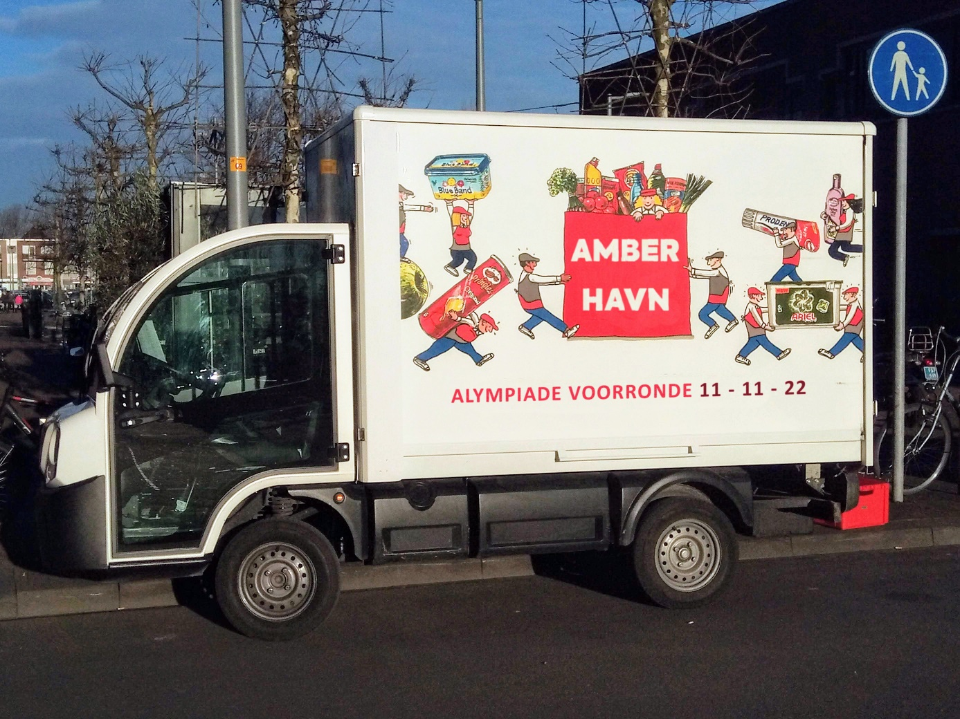
Alympiad preliminary round 11-11-22
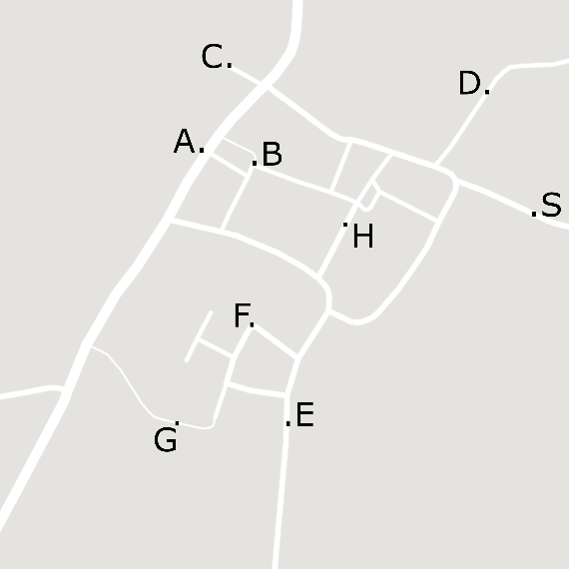

Colophon
The Mathematics Alympiad (Wiskunde Alympiade) is an initiative of the Freudenthal Institute, Utrecht University. The Alympiad committee is responsible for the organisation of the Alympiad and for producing the assignment. The committee consists of:
Marcel Daems
Gymnasium Sorghvliet, Den Haag
Eric van Dijk
Lorentz Casimir Lyceum, Eindhoven
Tom Goris
Fontys Lerarenopleiding, Tilburg
Dédé de Haan
Freudenthal Instituut, Utrecht
Senta Haas
Städtisches Gymnasium Hennef, Hennef, Duitsland
Kim Kaspers
Murmellius Gymnasium, Alkmaar
Johan van de Leur
Mathematisch Instituut, Universiteit Utrecht
Ruud Stolwijk
CITO, Arnhem; Vrijeschool Zutphen VO, Zutphen
Monica Wijers
Freudenthal Instituut, Utrecht

Secretariat:
Mariozee Wintermans
Freudenthal Instituut, Utrecht

Guide for the preliminary round assignment for the 2022/2023
Mathematics Alympiad
This assignment consists of three (introductory/further) assignments plus a final assignment. All knowledge and insights acquired from the previous assignments can (and must) be applied in the final assignment.
General advice for working on this Alympiad assignment:
- First read the full text of the assignment so you will know what you have to do.
- You may need to make (additional) assumptions for this assignment. Provide a clear description and justification of your choices.
- Keep an eye on the time you spend on the first three assignments; take plenty of time for the final assignment, at least 3 hours.
- If you have divided tasks, discuss the results with each other after each assignment.
- If you make changes in certain approaches, methods or procedures while working on the assignments, describe these adjustments in your report and indicate why you have made them.
- Mention the (online) sources you use.

Handing in:
- The final assignment
- The earlier assignments, optionally as appendices.

When you send in your work, the jury will receive a digital copy. If you have any appendices with your work, hand in everything in a zipped folder. Include the name of your school and your own names in the file name.
Judging:
These are some of the points that may be considered:
- Legibility and clarity of the final assignment;
- Completeness of the work;
- The use of mathematics;
- The argumentation used and justifications of choices that have been made;
- The depth to which work has been done;
- Manner of presentation: form, legibility, structure, use and function of attachments, etc.;
- (Mathematical) creativity in your elaboration of the assignments.

Have fun and good luck!

Introduction
Amberhavn's old town has many narrow streets. Heavy traffic can damage these streets and large vans often do not fit well in narrow streets, especially if they also need to turn around. The old city centre is therefore poorly accessible for traffic. Shops (and catering) in the city centre must, however, be supplied… In this Alympiad preliminary round assignment, we look at the (im)possibilities.
Please note: You may need to make (additional) assumptions for this assignment. Provide a clear description and justification of your choices.
Above you can see the map of the old town of Amberhavn. An enlarged version of this can be found in the appendix. The letters A to H indicate shops, S is the distribution centre from which the delivery vans depart. Three maps with restrictions for traffic can be found in the appendix. On map 1 you can see the limitation with regard to the total weight of the van: maximum 2000 kg. On map 2 and 3 you see restrictions regarding the length (maximum 6.00 m) and width (maximum 2.30 m). The scale of the floor plans is indicated in the appendix.
The stores to be stocked are also indicated on all floor plans.
There are three delivery vans available in the distribution centre S for deliveries:
Delivery van | 1 | 2 | 3
Length (m) | 5,30 | 7,40 | 5,00
Width (m) | 2,20 | 2,00 | 2,40
Empty weight (kg) | 2000 | 1800 | 1500

Starting assignments
Assignment A
For each of the three available vans, determine a possible route between the distribution centre S and shop G given the restrictions. Give an estimate of the length of the route driven.
Assignment B
You want to supply stores C, H and G (from distribution centre S) with one delivery van. It must be returned to S after resupply. Investigate which van (of the three given types) is most suitable for this and indicate the optimal route.

Further assignments
Assignment C:
Most shops in Amberhavn's old town are stocked several times a week. See the table below:
Shop | A | B | C | D | E | F | G | H
Must be supplied on | tue  wed  fri | mon  wed  fri | tue  thu | wed | mon  wed | mon  thu | tue  fri | mon  thu

Make a weekly schedule for the supply of the shops from the distribution centre. Also give the necessary routes and describe how the total travel distance can be kept as small as possible.

Final assignment:
Because of the costs, the management of the distribution centre decides that one of the three delivery vans must be sold. Your team is asked for substantiated advice. Draft this advice (using your previous findings).

Appendix
1: weight (maximum 2000 kg)
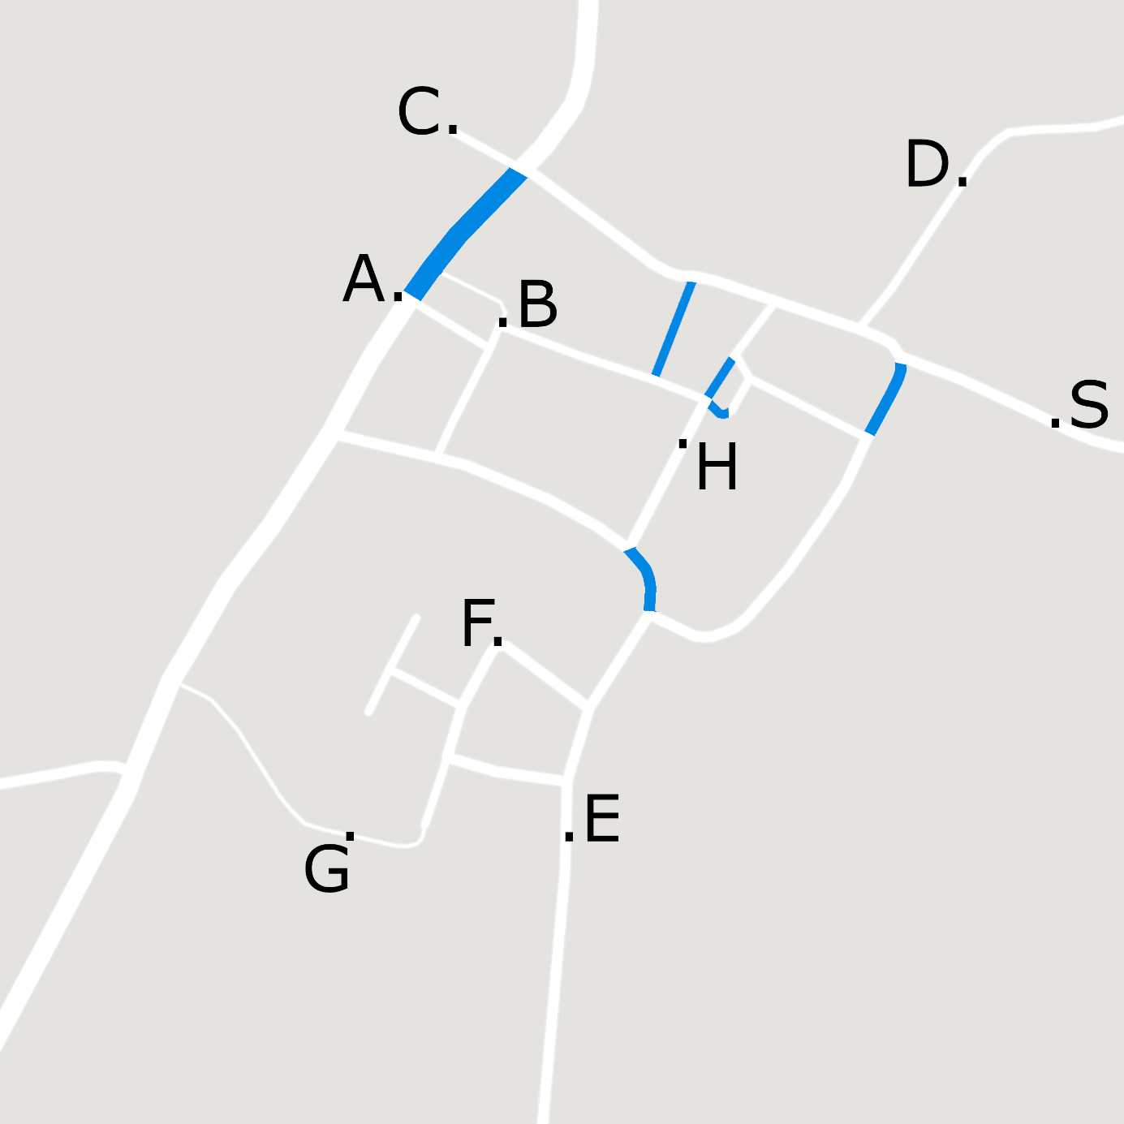
This map shows an area of ​​400 m by 400 m.

2: length (maximum 6,00 m)
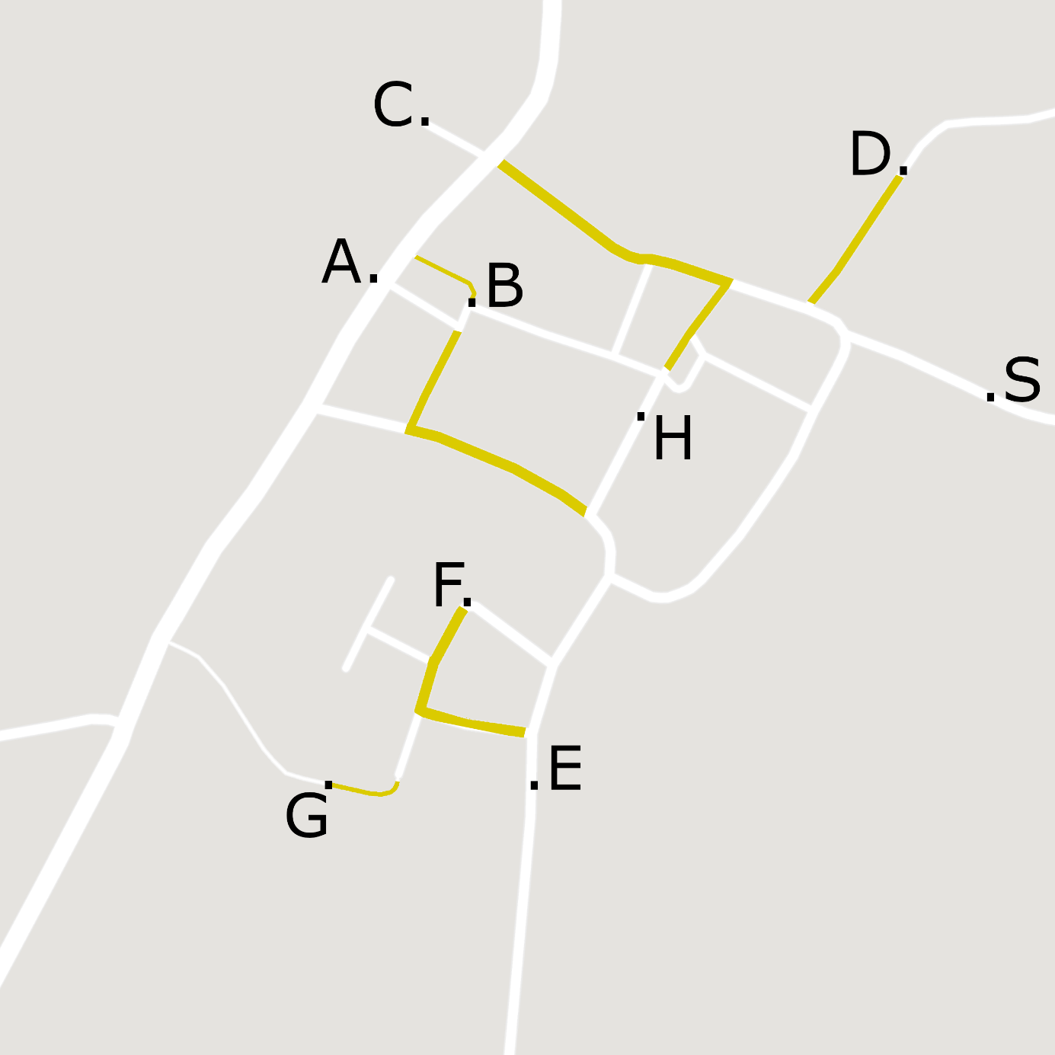
This map shows an area of ​​400 m by 400 m.

3: width (maximum 2,30 m)
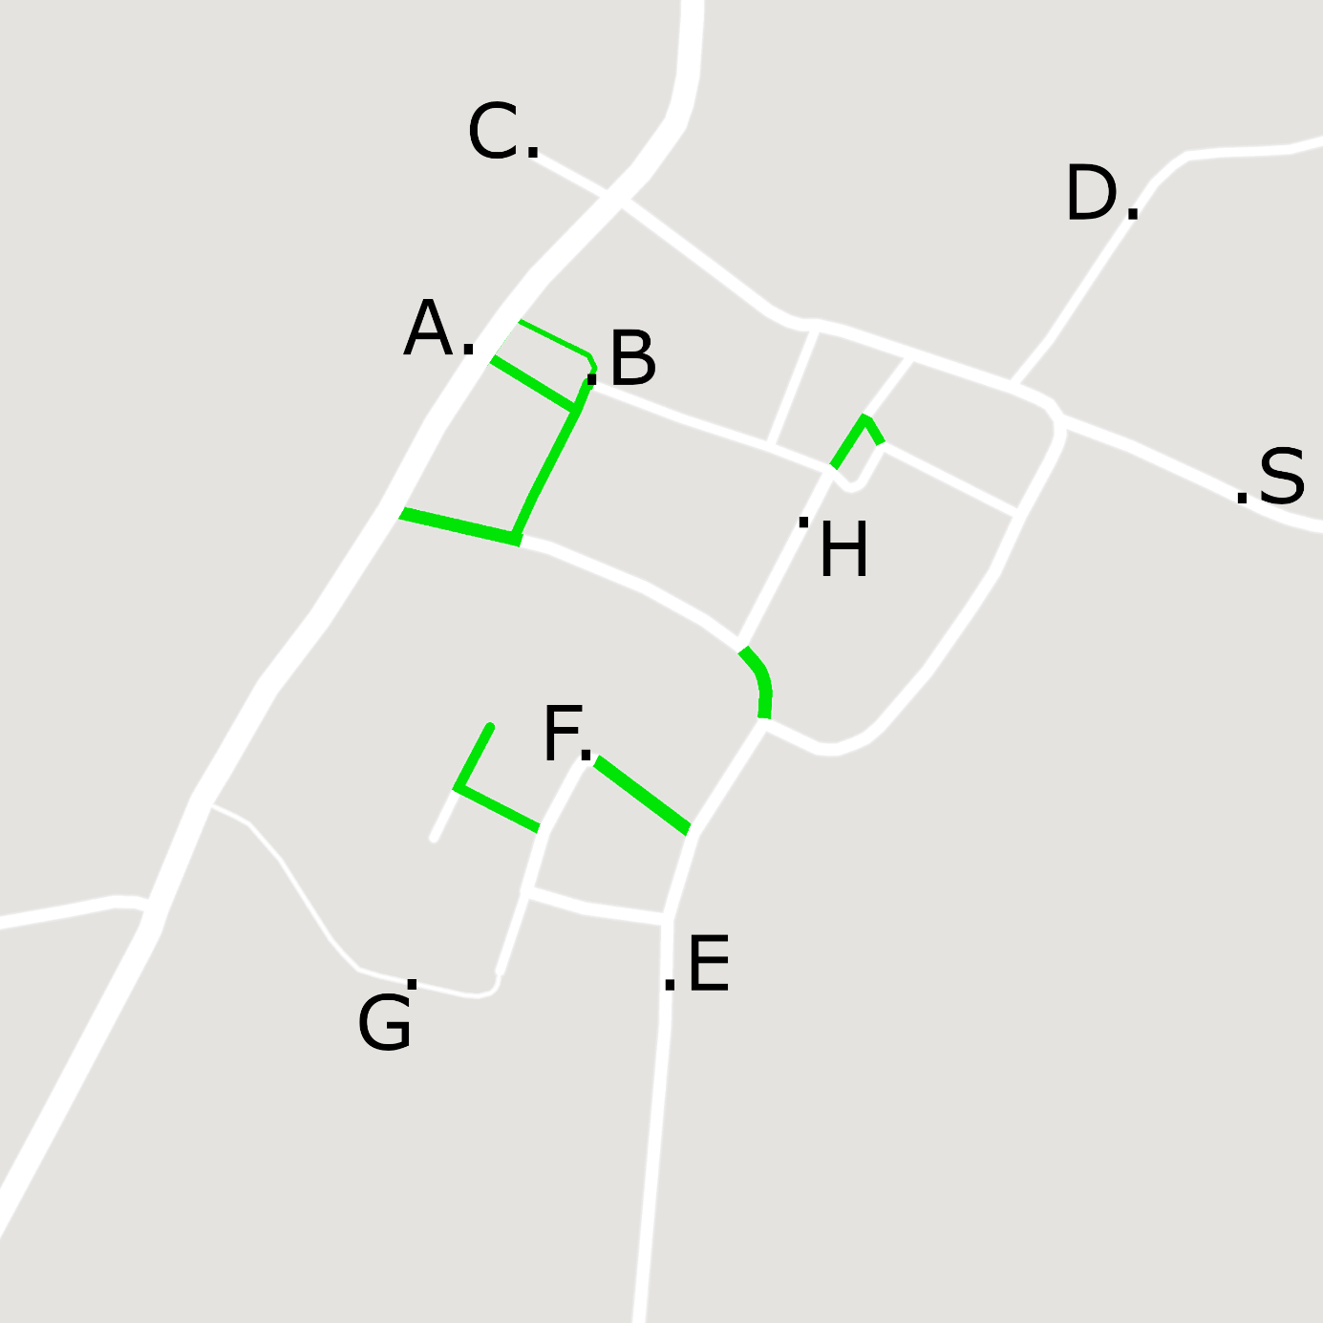
This map shows an area of ​​400 m by 400 m.

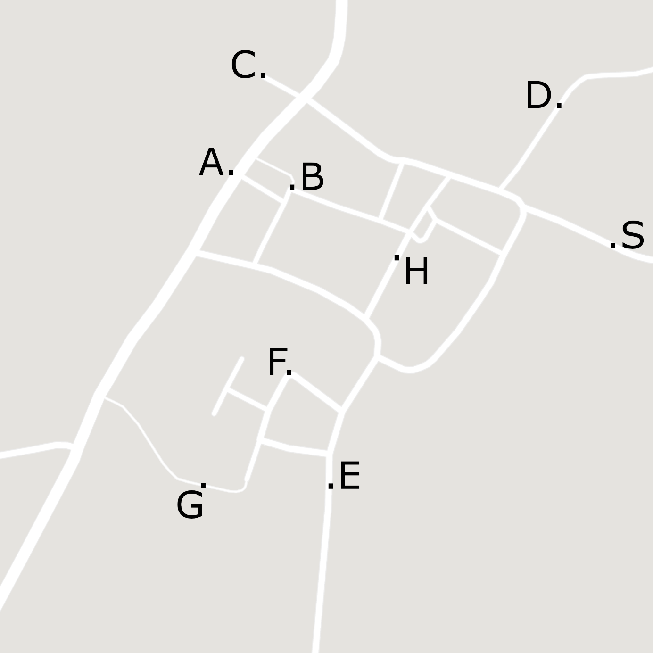
This map shows an area of ​​400 m by 400 m.

