Amberhavn vegetable garden association

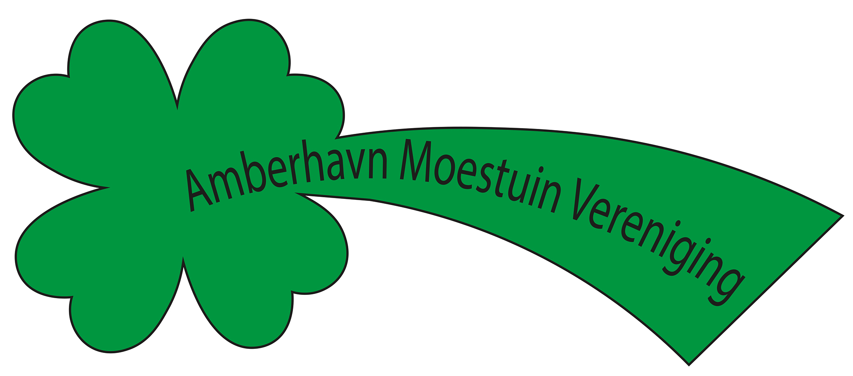

Preliminary round Alympiad November 12, 2021

Colophon
The Mathematics Alympiad (Wiskunde Alympiade) is an initiative of the Freudenthal Institute, Utrecht University. The Alympiad committee is responsible for the organisation of the Alympiad and for producing the assignment. The committee consists of:
Marcel Daems
Gymnasium Sorghvliet, Den Haag
Eric van Dijk
Lorentz Casimir Lyceum, Eindhoven
Tom Goris
Fontys Lerarenopleiding, Tilburg
Dédé de Haan
Freudenthal Instituut, Utrecht
Senta Haas
Städtisches Gymnasium Hennef, Hennef, Duitsland
Kim Kaspers
Murmellius Gymnasium, Alkmaar
Johan van de Leur
Mathematisch Instituut, Universiteit Utrecht
Ruud Stolwijk
CITO, Arnhem, Vrijeschool Zutphen VO, Zutphen
Monica Wijers
Freudenthal Instituut, Utrecht

Secretariat:
Mariozee Wintermans
Freudenthal Instituut, Utrecht

Guide for the preliminary round assignment for the 2021/2022 Mathematics Alympiad
This Mathematics Alympiad assignment consists of four (introductory) assignments and a final assignment: all knowledge and insights from the earlier assignments can (and must) be applied in the final assignment.
General advice for working on this Alympiad assignment:
- This Alympiad assignment has one (Excel) appendix ‘vegetable garden data).
- First read the full text of the assignment so you will know what you have to do.
- Keep an eye on the time you spend on the first four assignments; take plenty of time for the final assignment, at least three hours.
- If you divide up tasks, discuss the results with each other after every assignment.
- If you adapt certain approaches, methods or procedures while working on the assignments, describe your adaptations in your report and include why you made them.
- List the (internet) sources you have used.

Handing in:
• The final assignment
• The earlier assignments, optionally as appendices

When you send in your work, the jury will receive a digital copy. If you have any appendices with your work, hand in everything in a zipped folder. Include the name of your school and your own names in the file name.
Judging:
These are some of the points that may be considered:
- Legibility and clarity of the final assignment;
- How complete the work is;
- The use of mathematics;
- The argumentation used and justifications of choices that have been made;
- The depth to which work has been done;
- Manner of presentation: form, legibility, structure, use and function of attachments, etc.;
- (Mathematical) creativity in your elaboration of the assignments.

Have fun and good luck!

Amberhavn vegetable garden association (AMV)

AMV is a flourishing vegetable garden association in Amberhavn. Well over five years ago, Peter took over a vegetable garden, and ever since he’s enjoyed growing several vegetables: cauliflower, courgette and leeks. Over the last few years, the harvest has been more than enough to eat well from and enough is left over to give away to friends. So, after the first five years, Peter looks back on his harvests with pleasure. He has now decided to do a bit of reading on the art of growing vegetables. One thing he reads is that it is better to not grow the same vegetable on the same bit of land for two years in a row. Also, his harvest has been varying a lot, and not all of that is due to his inexperience in gardening, but also due to for example the weather.
At the moment this is the layout of Peter’s vegetable garden:
Courgette
32 m²
Cauliflower
40 m²
Shed
Leeks
15 m²

In the Appendix you will find a comprehensive table showing the annual average yield in kilograms per hectare of vegetables grown in Amberhavn in recent years. For courgette, leeks and cauliflower these are as follows:

Year | 2016 | 2017 | 2018 | 2019 | 2020
Yield | kg/ha | kg/ha | kg/ha | kg/ha | kg/ha
Courgette | 66500 | 70100 | 41900 | 40500 | 39300
Leeks | 35300 | 38200 | 34700 | 36300 | 35400
Cauliflower | 19000 | 19300 | 17600 | 17900 | 18500

Introductory assignment 1
Find out how many kilos of vegetables Peter will have harvested in total (approximately) in the years 2016 to 2020, based on this data.

Introductory assignment 2
If Peter had applied the advice to switch, how many kilograms of vegetables could he have had in total? Assume that Peter kept the same plot layout every year, only growing courgette, leeks and cauliflower, but not the same vegetable in the same plot two years in a row. Explain how you arrived at this layout.

In his search for the better vegetable garden, Peter starts by going through the sowing calendar. For example, when the courgette is harvested, he could plant something else there. He notices that some vegetables can be harvested early, some late and some vegetables can be harvested several times. Some vegetables can also be harvested quickly, others take much longer to grow. The appendix lists the period in which they can be planted and harvested for a number of vegetables. Vegetables do not necessarily have to be harvested immediately, you can often leave them in the ground for a while, so a harvest interval is also listed for each vegetable. After reading this information, Peter decides to grow more types of vegetables. He makes a new layout for this with more plots (see below). He wants to set up his vegetable garden so that there is something in the ground in every plot as much as possible all year round.

15 m²
19 m²
Schuur

7 m²

19 m²
15 m²

7 m²

Assignment 3
Make an appropriate annual schedule based on the sowing calendar in the appendix. Show in your annual schedule when and what Peter harvests and sows over the year. Make sure that Peter grows as many different kinds of vegetables as possible.

Peter reads on and immerses himself in crop rotation. He already knew that it is better not to grow a vegetable twice in succession on the same plot, but it turns out that there is more to it: vegetable varieties (indicated in the sowing calendar) should not be grown twice in succession on the same soil. So, for example, it is better not to plant legumes twice in succession on the same plot.

Assignment 4
Based on your annual schedule from assignment 3, make an appropriate annual schedule for the following year. Again, make sure that the total yield is as large as possible.

Peter likes to be busy in his vegetable garden and would like to combine this with something useful for society. He therefore decides to put together food packages for the food bank with two of his vegetable garden friends (who have the same size vegetable garden as Peter). In consultation with the food bank, they arrive at the following requirements for such a food package:

- Total 4 kilo
- 1 kilo of potatoes
- At least 3 of the 5 types of vegetables (leaf, pod, root, cabbage and fruit)
- At least 500 grams per vegetable
Naturally, Peter and his friends want to be able to deliver as many beautiful, fresh and varied vegetable packages as possible. They also want to be able to do this all year round. It is useful that some vegetables can be stored after harvesting. If applicable, you will find the maximum storage time listed in the sowing calendar

Final Assignment
Find out how Peter and his friends can make this happen. In any case, make a substantiated estimate of the number of packages they can deliver.

