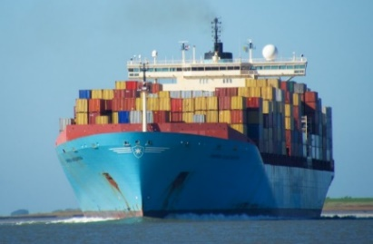
Back and forth through the canal

preliminary round of the 35th Alympiad
December 1, 2023

Colophon
The Mathematics Alympiad is an initiative of the Freudenthal Institute, Utrecht University. The Alympiad committee is responsible for organizing the Alympiad and producing the assignment.

The Alympiad committee consists of:

Marcel Daems
Gymnasium Sorghvliet, The Hague
Eric van Dijk
Lorentz Casimir Lyceum, Eindhoven
Tom Goris
Fontys Teacher Training, Tilburg
Dédé de Haan
Freudenthal Institute, Utrecht
Senta Haas
Städtisches Gymnasium Hennef, Hennef, Germany
Kim Kaspers
Murmellius Gymnasium, Alkmaar
Johan van de Leur
Mathematical Institute, Utrecht University
Ruud Stolwijk
CITO, Arnhem; Waldorf school Zutphen VO, Zutphen
Monica Wijers
Freudenthal Institute, Utrecht
Secretariat:
Mariozee Wintermans
Freudenthal Institute, Utrecht

Work instructions for the preliminary assignment of the Mathematics Alympiad 2023/2024
This preliminary round assignment consists of nine (entry/follow-up) assignments plus two final assignments. All knowledge and insights acquired from the first nine assignments can (and must) be applied in the final assignments.
General advice when working on this Alympiad assignment:
- First read the entire text of the assignment so you will know what you have to do.
- It may be necessary to make (additional) assumptions for this assignment. Provide a clear description and justification of your choices.
- Keep an eye on the time you spend on the first assignments; take plenty of time for the two final assignments.
- If you have divided tasks, discuss the results with each other after each assignment.
- If you change certain approaches, methods or procedures while working on the assignments, describe these in your report and explain why you made them.
- Mention any (internet) sources you use.
To hand in:
- The two final assignments
- The previous assignments, possibly as attachment(s)
When your work is submitted, the jury will receive a digital copy of your work. If you have any attachments to the paper, submit everything in a zipped folder. Include the name of the school and your own names in the file name.
Judgement:
The assessment may take into account, among other things:
- the readability and clarity of the final assignments;
- the completeness of the work;
- the use of mathematics;
- the argumentation used and the justification for choices made;
- the depth with which things have been done;
- the method of presentation: including the form, readability, structure, use and function of appendices;
- the (mathematical) creativity in the elaboration of the assignments.

Have fun and good luck!

Introduction
The North-South Canal is located in the vicinity of Amberhavn. This canal, 90 km long and 100 meters wide, is an important artery for international trade to and from Amberhavn. There are several towns and villages along the canal. The canal is an important connection for cargo ships in both directions.
Cargo ships have become much larger in recent years: Most cargo ships that navigate the canal are 300 meters long and 60 meters wide. In this assignment we assume this size of ship. Furthermore, we assume that all ships sail at a speed of 15 km/hour.
The North-South Canal has one place where ships can pass each other. This passing area is 5 km long and has a width of 50 meters. Below, you see a sketch (not to scale) of the canal and the location of the passing area.

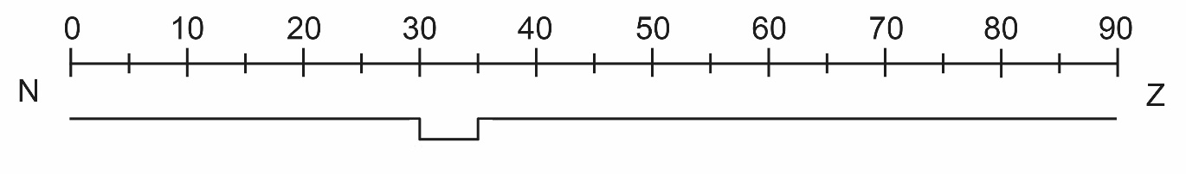

Entry level assignments: single ships
- A ship arrives at the beginning of the canal from the north at 5:00 am. By what time will the ship have passed through the canal if there is no oncoming traffic?
- Ships leave at 5:00 am from both the north and the south. These ships therefore have to pass each other - and that can only be done in one place. Find out by what time both ships will have passed through the entire canal. Indicate which ship must wait in the passing area along the route, and also how long this wait will take.

Below, you see a so-called sailing graph, in which the canal navigation of two ships is shown by non-dotted lines. You see that the ship sailing from south to north does so without stopping. The ship sailing from north to south must wait in the passing area along the way. In the sailing graph you also see a diagonal dotted line.
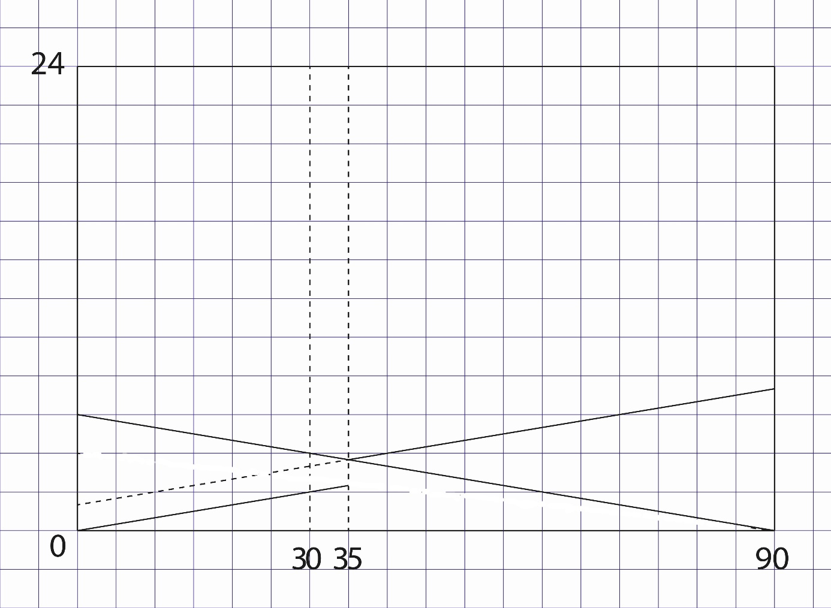
- Describe what the diagonal dotted line means. Start by determining what information both the axes provide.
- Investigate how many minutes later the ship from the north can depart so that this ship does not have to stop along the route.
- Explain why it would not be convenient if a ship departed from the north every hour.

Middle part: ships and convoys
To ensure that the canal can be used properly in both directions, ships sail through the canal in groups. These groups are called convoys. In a convoy, a group of ships sails at the same speed and with a fixed distance between them.
The great thing about sailing in convoys is that you can plan the passage well: with all individual ships this is much more complicated and takes more time. With convoys it obviously takes a while before the entire group has left.
At 00:00, a convoy of six ships from the north arrives at the beginning of the canal. At the same time, one ship departs from the south.
- What time will the last ship in the convoy have entered the canal? Indicate clearly which assumption(s) you are using.
The sailing graph below shows that the single ship from the south continues north without stopping, while the convoy (sailing from north to south) has used the passing area.
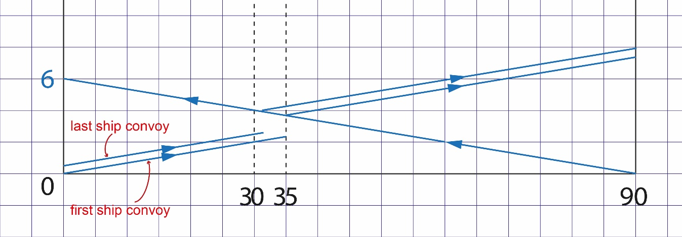

- Does the mutual distance in the sailing graph correspond to the mutual distance you selected in exercise 6?
The following rules apply to the passing area:
- in the passing area, ships can move slowly or be stationary;
- a ship must wait in the passing area before leaving until no more ships from the convoy are entering;
- a ship must wait in the passing area before leaving until no ship from the opposite direction is passing in the canal.

- Using the sailing graph, investigate what time the entire convoy sailed through the entire canal. Clearly describe the journey of each ship in the convoy, especially the part in the passing area.
- At 00:00 two convoys, each of ten ships, leave: one convoy departs from the north and the other from the south. Describe the journey of both convoys as precisely as possible. Display the journey of both convoys in a sailing graph (use the worksheet for this).
Final assignments
Due to the limited passage options, large parts of the canal are empty at certain times: no ships are sailing at that time. The question is therefore how you could make better use of the canal’s capacity.
- Investigate the maximum number of ships that can sail through the canal in 24 hours (from S to N and from N to S). Make a schedule or a sailing chart for optimal use of the canal. In any case, take the following aspects into account:
- the number of convoys
- the number of ships per convoy
- the times at which the passing area is passed

Increasing the capacity of the canal would of course allow more ships to pass through the canal per 24 hours. For example, you can consider the following options - but your own suggestions are of course also welcome:
- make the existing passing area twice as long (so that, for example, longer convoys become possible)
- create a second passing area of 5 km length between 55 and 60 km.
- create a second passing area in another place.
- …
- Provide well-founded advice as to which option is best. Do this by investigating which option allows the most convoys to sail the canal per 24 hours.

